Final task:

For our final task We are going to analyse a web application designed by us.

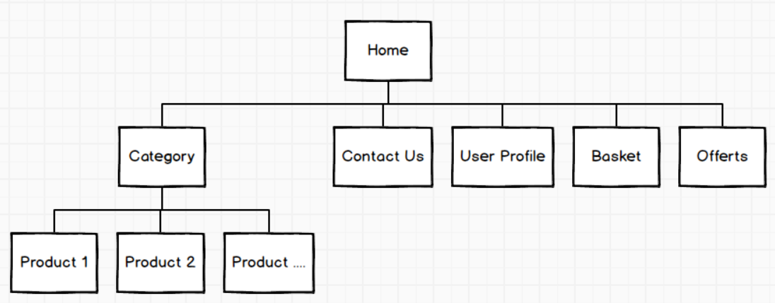

The colours we will use on this website will be shades of orange with black lettering. The background will be a pastel blue and the footer will be the same darker blue. The font we will use will be Sans-serif.

At the top left of the home page you will see our logo which, if you click on it, will take you to the home page.

Next to it we will find a counter that will show us how much time is left for our discounted or sale products.

To the right of it we have the search bar in case we want to make a more specific search within the page.

Finally, in the top right-hand corner we will find the registration, offers and basket icons that will take us directly to that part of our website.

In the body of our website you will find a list of the products offered by our shop by categories and sections.

At the bottom of the page you will find the terms of use of the shop and our social networks and contact information.

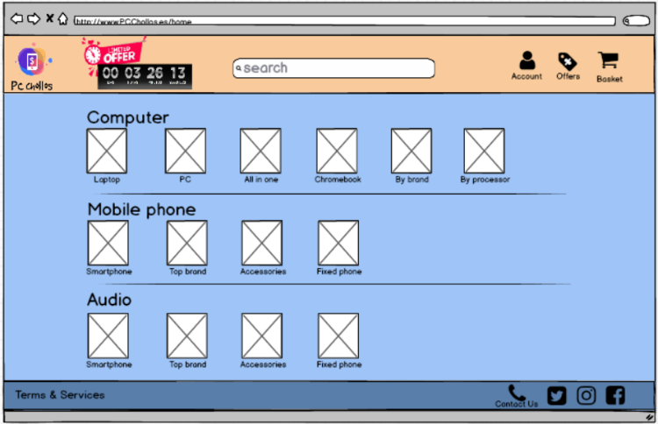 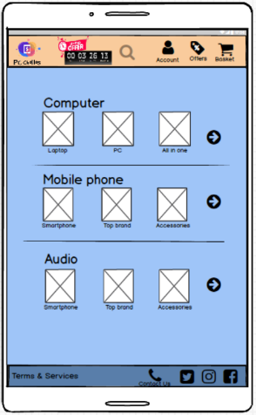

If we enter any of the pages we will find the same structure both in the header and in the footer of the page but in the body we will find a sandwich for the filters, the breadcrumbs to be able to return to a specific place in the web and the products that we offer in that category.

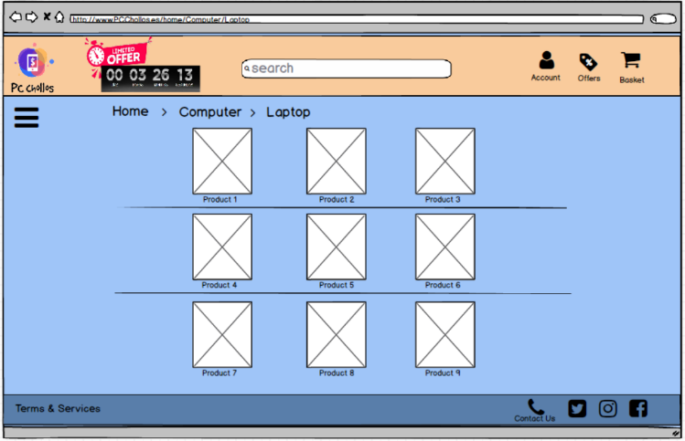 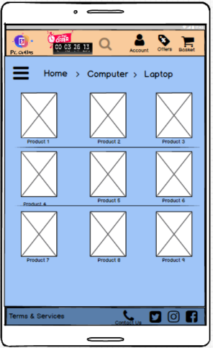

If we go to the page of a specific product we will find the breadcrumbs to be able to return to a specific place in the web, images of it product, a detailed description its price and the option of add to the basket or to buy it.

Also below this we will have the comments and opinions of our buyers and some photos of the product in person.

